CREATIVE EDUCATIONAL SERVICES

**END OF TERM 2 EXAMINATION-2024**

**INTEGRATED SCIENCE - P.6**

**Time Allowed: 2Hrs 15 MIN**

**Name:………………………………………………………………………………..**

**Stream:………………………………..**

**Read the following instructions carefully:**

|  |  |  |
| --- | --- | --- |
| **FOR EXAMINER’S USEONLY** | | |
| **Qn. No** | **MARK** | **SIGN** |
| **1 – 10** |  |  |
| **11 – 20** |  |  |
| **21 – 30** |  |  |
| **31 – 40** |  |  |
| **41 – 43** |  |  |
| **44 – 46** |  |  |
| **47 – 49** |  |  |
| **50 – 52** |  |  |
| **53 – 55** |  |  |
| **TOTAL** |  |  |

1. The paper has **two** sections: **A** and **B**
2. Section **A** has 40 questions (40 marks)
3. Section **B** has 15 questions (60 marks)
4. Answer **ALL** questions. All answers to both Sections A

and B must be written in the spaces provided.

1. All answers must be written using a blue or black ball

point pen or ink. Diagrams should be drawn in pencil.

1. Unnecessary alteration of work may lead to loss of marks.
2. Any handwriting that cannot be easily read may lead to

loss of marks.

1. Do **not** fill anything in the boxes indicated for Examiner’s

use only.

***Turn over***

**SECTION A: 40 MARKS**

1. In which way do animals depend on plants

_________________________________________________________________________

1. Give any one method through which soil is formed

________________________________________________________________________

1. What type of energy is processed by a baby sleeping in cot?

________________________________________________________________________

1. State the practice that helps to control poultry vices in poultry management.

________________________________________________________________________

1. State any one sign of child suffering from marasmus.

________________________________________________________________________

1. Write anyone condition necessary during seed germination

________________________________________________________________________

1. By what process does the exchange of gases take place in the alveoli?

________________________________________________________________________

1. Mention any one effect of smoking to the family.

________________________________________________________________________

1. How is the digestive juice produced in the mouth important during digestion of food?

________________________________________________________________________

**The diagram below shows a part of a flower. Study and use it to answer questions 10 and 11**

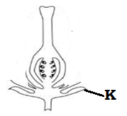

1. Which part of a flower is shown?

______________________________________________

1. Give the function of part marked K

_____________________________________________

1. In which way is heat transfer by radiation important to people’s daily life?

________________________________________________________________________

1. Mention one example of a natural fiber

________________________________________________________________________

1. Write the importance of sugar to a dehydrated person.

________________________________________________________________________

1. State any one property of matter.

________________________________________________________________________

1. Why is the coiled delivery tube passed in a cold water during distillation of alcohol

________________________________________________________________________

1. In which way are artificial fertilizers dangerous to the soil?

________________________________________________________________________

**The diagram below shown a fruit. Study and use it to answer questions 18 and 19**

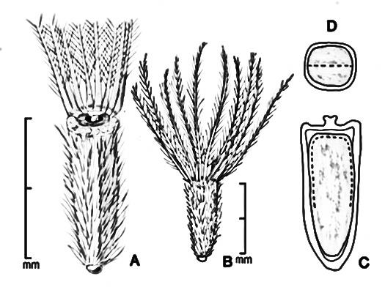

1. State the mode of seed dispersal that the fruit undergo.

_____________________________________________________

1. How is the above fruit adopted to the above mode of seed dispersal?

________________________________________________________________________

1. Apart from the liver, mention any other body organ destroyed by excessive consumption of alcohol.

________________________________________________________________________

1. Which form of energy enables the eggs of fish to hatch into fry?

________________________________________________________________________

1. State one reason why a sty should be constructed with a slanting floor.

________________________________________________________________________

1. How does sound from a radio reach a person who is five meters away?

________________________________________________________________________

1. Why are people advised to eat well cooked pork?

________________________________________________________________________

1. Mention one way plants reduce the rate of transpiration.

________________________________________________________________________

1. Why is distilled water not good for drinking

________________________________________________________________________

1. Which mammals uses vibrations for movements.

________________________________________________________________________

1. How do mushrooms reproduce?

________________________________________________________________________

1. Name the amphibians that lays eggs in the pattern below.

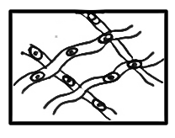___________________________________________________

1. Mention any one way in which animals are important as a living resources in the environment.

________________________________________________________________________

1. State the weather instrument used for measuring the length of time the sun has shone in a day.

________________________________________________________________________

1. Why are thick curtains and soft board placed on the wall of theatre halls?

________________________________________________________________________

1. In which body parts are the red blood cells being made in the body.

________________________________________________________________________

1. Name one type of alcohol.

________________________________________________________________________

1. State the importance of iodine in the body.

________________________________________________________________________

**Use the diagram below to answer the questions**

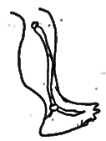

1. What type of fracture is shown above

________________________________________________________________________

1. Why is the fracture mentioned in (36) common in children?

________________________________________________________________________

1. List down any one example of an arachnid

________________________________________________________________________

1. State the type of fertilization occurs in amphibians.

________________________________________________________________________

1. How is the foot of a swimming bird adopted to its function?

________________________________________________________________________

**SECTION B:60 MARKS**

1. (a)What are essential drugs?

________________________________________________________________________

b.Mention the essential drugs that help to boost the immunity in infants.

________________________________________________________________________

c. Mention any two ways drugs are introduced into the body.

(i)_______________________________________________________________________(ii)______________________________________________________________________

1. (a)What is dehydration?

________________________________________________________________________

b. Name two mineral salts lost during dehydration

(i)_______________________________________________________________________(ii)______________________________________________________________________

c. Why is dehydrated person given ORS?

________________________________________________________________________

1. **The diagram below shows a method of producing alcohol. Use it to answer the questions that follow**

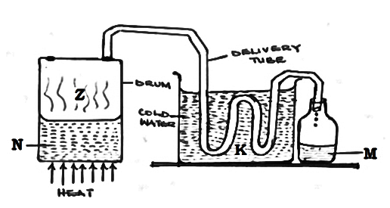

1. Mention the method of producing alcohol shown above.

________________________________________________________________________

1. Name the parts marked M and N.

M ______________________________________________________________

N ______________________________________________________________

1. Give one reason why people take alcohol.

________________________________________________________________________

1. (a)In which way are scales important to a fish

________________________________________________________________________

b. Which part of a fish has the same duty as the human ear?

________________________________________________________________________

c. Why does a fish die shortly when is removed from water?

________________________________________________________________________

1. How do fish help to control Malaria?

________________________________________________________________________

1. (a)State the effect of heat on;

Water ___________________________________________________________

Ice ______________________________________________________________

b. Why is air regarded as matter?

_________________________________________________________________________

c. In which state of matter is vapour?

________________________________________________________________________

1. (a)Give two similarities between bacteria and fungi

(i)_______________________________________________________________________(ii)______________________________________________________________________

b. Identify the fungi that is useful in the process of fermentation.

________________________________________________________________________

c. Give any one example of a useful bacteria

________________________________________________________________________

1. (a)What are biological changes?

________________________________________________________________________

b. Give one characteristic of biological change.

________________________________________________________________________

c. How is burning similar to rusting

________________________________________________________________________

d. Mention one example of chemical change to the environment

________________________________________________________________________

1. **The diagram below shows a method of keeping goats. Use it to answer the questions that follow.**

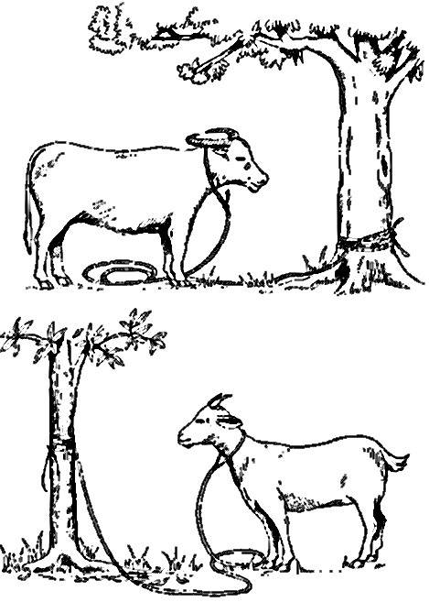

1. Name the method of grazing goats shown in the diagram above

_________________________________________________________________________

1. Give any one advantage of using the method shown above to the farmer.

_____________________________________________________________________

1. Why is it advisable to keep the goat’s house clean?

_______________________________________________________________________

1. Identify one example of a goat that provides mohair

_______________________________________________________________________

1. (a)What is food?

_______________________________________________________________________

b. Mention any two examples of blocks of food path.

(i)_______________________________________________________________________(ii)______________________________________________________________________

c. Give any one example of bad eating habits.

________________________________________________________________________

1. (a)What do you understand by the term soil erosion

________________________________________________________________________

b. State two causes of soil erosion.

(i)_______________________________________________________________________(ii)______________________________________________________________________

1. Apart from wind, mention any other two agents of soil erosion.

(i)_______________________________________________________________________(ii)______________________________________________________________________

1. (a)Mention any two dangers of strong wind in an area.

(i)_______________________________________________________________________(ii)______________________________________________________________________

b. State two uses of wind to people.

(i)_______________________________________________________________________(ii)______________________________________________________________________

1. The diagram below shows how to measure volume of objects use it to answer the questions that follow.

70

60 2nd level

50

40

30 1st level

20

10

0

1. Find the volume of the object above

__________________________________________________________________

1. If the density of the object above is 40kg find its mass.

__________________________________________________________________

1. Why did the object above sink in water?

__________________________________________________________________

1. When is the above method used to find the volume of such an object?

_________________________________________________________________

1. (a)Name any two examples of arteries in the human body.

(i)_______________________________________________________________________(ii)______________________________________________________________________

b. Which part of the skeleton protects the heart and lungs from any mechanical harm?

__________________________________________________________________

c. Name the part of the heart that prevents the oxygenated blood from mixing with deoxygenated blood

__________________________________________________________________

1. (a)Which process in plants follows pollination?

__________________________________________________________________

b. Write the two type of pollination.

(i)_______________________________________________________________________(ii)______________________________________________________________________

c. Name the part of the flower that attracts the living agents of pollination.

________________________________________________________________________

1. (a)State the main source of heat and light energy in the environment.

_______________________________________________________________________

b. Give any two importance of heat energy in the environment

(i)_______________________________________________________________________(ii)______________________________________________________________________

c. How does heat energy help in the formation of rainfall?

_________________________________________________________________________